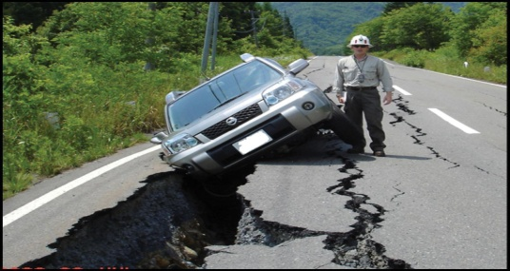
August
Tip of the Month

What To Do If You Are In Your Car During An Earthquake
Earthquakes can strike at any time, even when you are driving. It is important to be prepared and follow these tips:
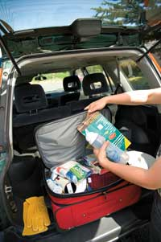
- Keep an emergency kit in your car
- Try to make your way to the shoulder or right of the road as safely as possible
- Make sure you’re not under an overpass, electrical wires , light poles, or tall trees
- Stay in your car until the shaking stops
- Check to ensure your passengers are not injured
- Make a visual assessment of the road conditions before starting out again
- Stay tuned to local broadcasts to find out which roads have been affected
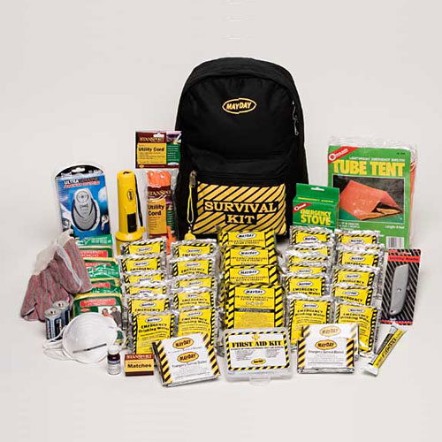
- If the roads are not safe, stay put and wait for help
What Items Should Be In My Car Emergency Kit?
- Water
- Food or high energy snack bars
- First Aid supplies
- Emergency blanket
- Flashlight or glow sticks
- Battery powered radio
For more information visit www.kitsapdem.org

